HYDROCARBONS

BEHAVIOUR OBJECTIVES
At the end of this lesson, students should be able to:
- discuss the occurrence of hydrocarbon.
- explain the tetravalent nature of carbon.
- define and classify hydrocarbons.
- expound and define homologous series, functional groups, isomerism.
- explain 5 characteristics of a typical homologous series.

HYDROCARBONS
Hydrocarbons are organic compounds that contain hydrogen and carbon only. Its general formula is C_{x}H_{y}. The source of hydrocarbon is crude oil; which is a mixture of gaseous, liquid and solid alkane, alkene, cycloalkanes and aromatic hydrocarbons.

HYDROCARBONS IN NATURE
Hydrocarbons are naturally occurring chemical compounds that consist of hydrogen and carbon found in crude oil, natural gas, and coal.

TETRAVALENT NATURE OF CARBON
Carbon is the sixth element on the periodic table, with configuration: 1s² 2s² 2p². It has the capability to expand its octet to accommodate 4 bonds, in the form 1s² 2s¹ 2px¹ 2py¹ 2pz¹, since p has 3 orbitals and singly filled is more preferred due to increased stability. This is due to its small size.

CLASSIFICATION OF HYDROCARBON
Hydrocarbon are classified into two main groups;
ALIPHATIC: are straight chain or branched hydrocarbons. Types of aliphatic hydrocarbon include;
Alkane: C_{n}H_{2n+2} carbon-carbon single bond.
Alkene: C_{n}H_{2n} carbon-carbon double bonds.
Alkyne: C_{n}H_{2n-2} carbon-carbon triple bonds.

AROMATIC: cyclic, planar compounds that resemble benzene in electronic configuration and chemical behaviour. e.g. benzene, naphthalene, anthracene.

CLASSIFICATION OF HYDROCARBON BASED ON SATURATION
Saturated Hydrocarbon: contains only carbon-carbon single bonds. The Alkane family.
Unsaturated Hydrocarbon: contains carbon-carbon double or triple bonds. e.g. alkene, alkyne, aromatic hydrocarbons.

HOMOLOGOUS SERIES
A family of organic compounds which follows a regular structural pattern, in which each successive member differs in its molecular by a CH₂ group. e.g. Alkanes (C_{n}H_{2n+2}), Alkenes (C_{n}H_{2n}), Alkynes (C_{n}H_{2n-2}). Each member of the series is called homologue.

CHARACTERISTICS OF HOMOLGOUS SERIES
- All members conform to a general molecular formula. E.g. for alkanes; C_{n}H_{2n+2}.
- Each successive member differs in molecular formula by -CH₂ group.
- All members are prepared by same method.
- All members undergo similar chemical reaction.

FUNCTIONAL GROUP
An atom, a radical or a bond added to a homologous series, which determines the chemical properties of the series. e.g. hydroxyl -OH, amino group -NH₂, carboxyl group -CO₂.
Functional group determines the chemical properties of the compound. Functional group promotes reactivity.

Homologous Series | Functional Group
Alkane  Alkene  Alkyne  Alkanol  Alkanoic acid  Alkanal  Alkanonoe  Alkanoate  Amines  Alkoxy alkane | R–C-H  R-C = C-R  R-C $≡$ C-H  R-OH  R-COOH  R-CHO  R-C=O  R-COO-R`  R-NH₂  R-O-R

ISOMERISM
Isomerism is the occurrence of two or more compounds with the same molecular formula but different structural formula. This is common in organic chemistry; the compounds are called isomers of one another.

TYPES OF ISOMERS
- Structural isomers: the compounds have the same molecular formula but different structural arrangement of carbon atoms.
Types:
Chain Isomerism - refers to the compounds that have the same molecular formula but different carbon chain arrangements.
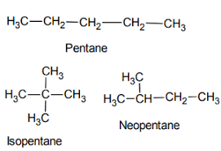

Functional Isomerism - refers to the compounds that have the same chemical formula but different functional groups attached to them.
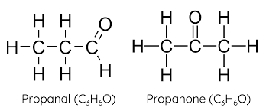

Positional isomerism – When two or more compounds have same molecular formula but differ in the position of substituent or functional group on the carbon atom.
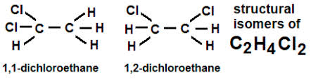

- Stereoisomerism:
is a form of isomerism in which molecules have the same molecular formula and sequence of bonded atoms, but differ in the three-dimensional orientations of their atoms in space.
Types
Geometric Isomerism (cis and trans): describes certain arrangements of atoms within molecules. The prefixes "cis" and "trans" are from Latin: "this side of" and "the other side of", respectively.
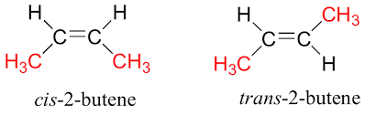

Optical Isomerism: Isomerism in which the isomers have the same molecular and structural formula but different spatial arrangements of the atoms which have non-superimposable mirror images.

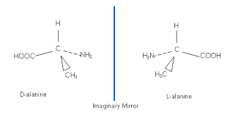

DRILL QUESTIONS

- Homologues have the same …………….?
- Empirical formula
- Structural formula
- General formula
- Molecular formula

- Which of the following statement is not true about hydrocarbons?
- They are all saturated compounds
- They are organic compounds
- They contain carbon and hydrogen
- They could be gases, liquids or solids

- Functional groups determine the ………………… of the compounds
- Ground state
- Physical properties
- Chemical properties
- Solubility

- ……….….. is the occurrence of two or more compounds with the same molecular formula but different structural formula?
- Functional groups
- Homologous series
- Saturated hydrocarbons
- Isomerism

- Alkanes are …………. Hydrocarbons
- Unsaturated
- Aromatic
- Saturated
- Simple

ANSWER
- C
- A
- C
- D
- C

